Assiut University

Faculty of Computers & Information

Department of …

**Graduation Project**

**Academic Year 2022-2023**

Classroom activity recognition for power saving

Project Proposal

Classroom activity recognition for power saving

Project Proposal

Project Team

Mostafa Usama Ahmed – 162019153

Mohamed Nabil Hassan – 162019141

Mohamed Ramadan Farouk – 162019129

Nourhan Mahmoud Hassan– 162019172

Manar Mohamed Sayed– 162019161

Sondos Osama Mohamed – 162019071

Supervisor

Prof. Abdel-Rahman Hedar

**2022**

Table of Contents

Project Abstract 3

Project Objectives 3

Approaches and Methodology 4

Project Plan and Management 4

References 5

# Project Abstract

Universities use a dramatically large amount of energy, and quite a lot of this is unnecessarily wasted. This means that education facilities are spending a lot of their allocated budget on energy, despite potentially not using all that they are paying for, and as budgets are becoming more and more limited, saving energy through minimizing running costs and power wastage in universities, is a method that can come in very useful.

Electricity saving can be achieved through the efficient use of energy, such as turning off lights, fans, air conditioning, and other electrical appliance when not in use. This project aims to prevent wasting Electricity in the classroom by automatically implementing an IoT system that will detect and count the number of students entering and exiting the classroom using a sensor system and cameras. Based on this information system will decide whether to turn on the electrical devices or not. We will also add deep learning based on the recognized pattern for human activity recognition. The system will adjust the power based on this pattern.

The system will reduce the consumed energy, cost, and human resources by automating the process of lighting and ventilation.

# Project Objectives

Reduce the energy consumed in classrooms by automating the process of lighting and ventilation. This system will save up to 20% more power. It will also reduce the cost and human resources wasted. Since universities use a dramatically large amount of energy, this system will improve the current systems and save more resources. The system will be running by July 2023. To achieve such goals, we propose the following objectives:

1. Design data collection models for the sensor resources.
2. Design machine learning models to detect the human activity pattern.
3. Develop smart systems for classroom power control.

# Approaches and Methodology

* Use sensors to detect any motion in the classroom.
* Gathering data with cameras to identify activities.
* Represent classroom activities as a set of visual features extracted from video sequences or still images and recognize the underlying activity using several classification models.
* Pre-processing the collected data to remove any noise.
* Applying machine learning algorithms to classify the activities based on the extracted features.
* IoT to adjust the power consumption based on the activity.

# Project Plan and Management

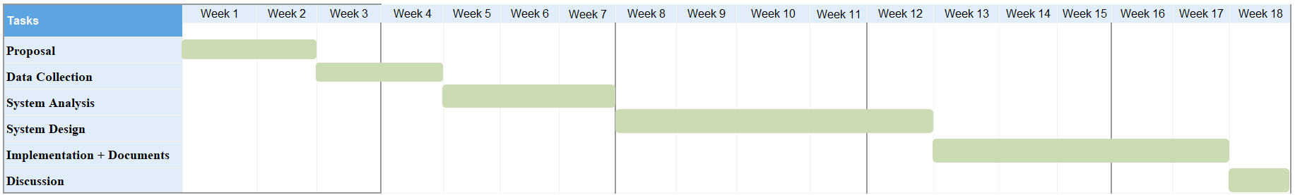**First Term**

|  |  |
| --- | --- |
| Task | Team Members |
| Project Proposal | **All team members** |
| Data Collection | **Nourhan Mahmoud,**  **Manar Mohamed** |
| System Analysis | **Mostafa Usama,**  **Mohamed Nabil** |
| System Design | **Mohamed Ramadan,**  **Manar Mohamed,**  **Nourhan Mahmoud** |
| Implementation + Documents | **Mostafa Usama,**  **Mohamed Nabil,**  **Sondos Osama** |
| Discussion | **All team members** |

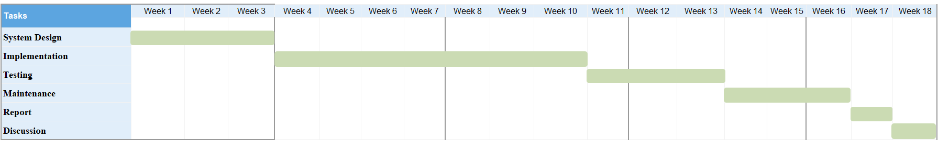**Second Term**

|  |  |
| --- | --- |
| Task | Team Members |
| System Design | **Mohamed Ramadan,**  **Manar Mohamed,**  **Nourhan Mahmoud** |
| Implementation | **Mostafa Usama,**  **Mohamed Nabil,**  **Sondos Osama** |
| Testing | **Nourhan Mahmoud,**  **Mohamed Ramadan** |
| Maintenance | **All team members** |
| Report | **All team members** |
| Discussion | **All team members** |

# References

[1] (Mohd Wafi Nasrudin, Mohd Ilman Jais, Iszaidy Ismail, Nur Asyikin Nordin, & Amir Nazren Abdul Rahim, Journal of Physics: Conference Series 2107 (2021) 012019)

[2] (Yunhao Liu; Zhiwen Yu; Bin Guo; Lina Yao; Dalin Zhang; Kaixuan Chen, ACM Computing Surveys Volume 54 Issue 4 May 2022 Article No.: 77pp 1–40)